Python Programming Assignment 1 Report

Student Name: | DHAKSHAN SREE S
Register Number: | 192419010
Course: | CSA0822-Python Programming
GitHub Repository: | 192419010DhakshanSree/ Python assignment for a village milk co-operative payment calculator
TASK 1 — Understand the Problem and Identify the Data
1. Identify all the inputs required by the program.
The program requires the following inputs:
- Farmer ID: Identifies the farmer supplying the milk.
- Litres: Specifies the quantity of milk supplied.
- Fat percentage: Indicates the fat content of the milk.
- SNF percentage: Indicates the Solids-Not-Fat content of the milk.
- Shift: Identifies the milk collection shift, such as morning or evening.
These inputs are used to calculate the milk rate and the payment due to the farmer.
2. Identify the outputs of the program.
The program produces the following outputs:
- Rate per litre: The amount paid for each litre based on milk quality.
- Payment amount: The amount payable for an individual milk delivery.
- Ten-day total: The total payment for all valid entries belonging to a farmer during ten days.
The payment for an entry is calculated by multiplying the quantity of milk by the rate per litre.
3. Identify the values that should be defined as named constants.
The following values should be defined as named constants:
Constant | Value | Purpose
BASE_RATE | ₹30.00 | Base payment per litre
STANDARD_FAT | 3.5% | Standard fat percentage
STANDARD_SNF | 8.5% | Standard SNF percentage
FAT_STEP_VALUE | ₹0.40 | Rate adjustment for each 0.1% fat step
SNF_STEP_VALUE | ₹0.30 | Rate adjustment for each 0.1% SNF step
MIN_FAT | 2.0% | Minimum permitted fat percentage
MAX_FAT | 7.0% | Maximum permitted fat percentage
Named constants make the program easier to understand and maintain. If the co-operative changes its rate card, the relevant values can be updated in one place instead of being changed throughout the program.
4. Classify the values according to their data types.
The appropriate Python data types are:
Value | Data type | Reason
Farmer ID | str | Identifies the farmer and may contain letters or leading zeros
Litres | float or Decimal | Represents the quantity of milk, including fractional litres
Fat percentage | float or Decimal | Represents the measured fat content
SNF percentage | float or Decimal | Represents the measured SNF content
Shift | str | Stores values such as morning or evening
Rate per litre | Decimal | Represents the calculated monetary rate
Payment amount | Decimal | Represents money accurately to the required decimal places
Ten-day total | Decimal | Stores the accumulated payment
Validation result | bool | Indicates whether an input is valid or invalid
Number of entries | int | Counts the milk records processed
For financial calculations, Decimal is preferable to float because binary floating-point arithmetic can introduce small precision errors. The program should use a consistent rounding policy when displaying or storing payments.
5. Define the validation rules.
The program should apply the following validation rules:
- Farmer ID must not be blank.
- Milk quantity must be numeric and non-negative.
- Fat percentage must be between 2.0% and 7.0%, inclusive.
- SNF percentage must be numeric and non-negative.
- Shift must not be blank and should match the permitted shift names.
- Invalid numeric input should be handled using exception handling, such as try and except ValueError.
- Invalid records should not be included in the payment total.
The assignment specifies a minimum fat percentage of 2.0% and a maximum of 7.0%. It does not specify a maximum SNF percentage, so an additional upper limit should only be introduced if the co-operative provides one.
6. State and justify the assumptions made in the design.
The following assumptions are used in the design:
- The base rate is ₹30.00 per litre when fat is 3.5% and SNF is 8.5%.
- Each 0.1% increase or decrease in fat changes the rate by ₹0.40 per litre.
- Each 0.1% increase or decrease in SNF changes the rate by ₹0.30 per litre.
- Fat and SNF step counts are calculated relative to their standard values and rounded to the nearest whole step.
- Milk quantity cannot be negative, but zero litres is permitted under the stated validation rule.
- Farmer ID and shift are required for identifying and organising the records.
- Payments are displayed to two decimal places, and the program should use a consistent monetary rounding policy.
- The ten-day total includes only valid milk entries belonging to the relevant farmer.
These assumptions provide a clear basis for implementing and testing the calculator. Any additional business rules, such as a maximum SNF value or a different rounding method, should be confirmed with the co-operative.
7. Additional Question — Alternative Design and Complexity
Question: Suppose each farmer's data is stored in separate variables, such as litres1, fat1 and snf1, instead of storing each entry in a list or tuple. Explain how the two approaches differ for 300 farmers. Analyse their time and space complexity for n entries, and explain which approach is more scalable.
Answer:
Storing every farmer's data in separate variables, such as litres1, fat1, snf1, litres2, fat2 and snf2, becomes difficult to manage when the number of farmers increases to 300. The programmer must create and maintain many variables, and processing them requires repetitive code. Adding more farmers also requires modifying the program.
Using a list of records or tuples is more suitable. Each record can contain the farmer ID, litres, fat percentage, SNF percentage and shift. A loop can process all records using the same code.
For example:
milk_entry = ("F001", 10.0, 3.5, 8.5, "Morning")
Many such records can be stored in a list and processed systematically.
Complexity analysis:
- Separate variables: Processing all n entries still requires O(n) time if each entry is processed once. Storing all the values requires O(n) total space, but the approach is difficult to maintain and extend.
- List or tuple-based records: Processing n entries takes O(n) time. Storing all entries requires O(n) space. A running total requires O(1) additional calculation space, excluding the records and any per-farmer totals that must be stored.
Both approaches may require O(n) space when all data is retained. However, a list or tuple provides a more organised and maintainable structure. It supports loops, reusable functions, validation and easier addition of new records.
Source Code
def analyze_requirements():
inputs = ["farmer_id (str)", "litres (float)", "fat_pct (float)", "snf_pct (float)", "shift (str)"]
outputs = ["rate_per_litre (float/Decimal)", "payout_amount (float/Decimal)", "ten_day_total (float/Decimal)"]
constants = {"BASE_RATE": 30.00, "FAT_STEP_VALUE": 0.40, "SNF_STEP_VALUE": 0.30}
rules = ["litres >= 0.0", "2.0 <= fat_pct <= 7.0", "snf_pct >= 0.0"]
print("=== TASK 1: Problem Requirements Analysis ===")
print("Inputs :", inputs)
print("Outputs :", outputs)
print("Constants :", constants)
print("Rules :", rules)
if __name__ == "__main__":
analyze_requirements()

Execution Evidence Screenshot
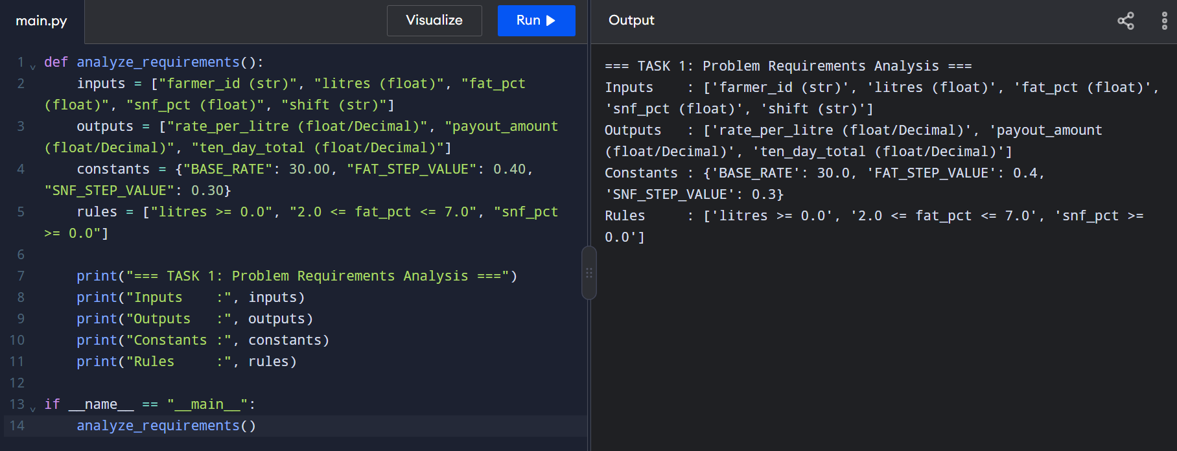
TASK 2 — Explore Values and Types in Python Interpreter
1. Find the type of each value using type().
The type() function identifies the data type of a value in Python.
Expression | Output
type(10) | <class 'int'>
type(10.0) | <class 'float'>
type("10") | <class 'str'>
type(True) | <class 'bool'>
type([10, 8.5]) | <class 'list'>
An integer stores whole numbers, a float stores floating-point numbers, a string stores text, a Boolean represents True or False, and a list stores multiple values in a single collection.
2. Demonstrate the results of the arithmetic operations.
The results of the given expressions are:
Expression | Result | Explanation
7 / 2 | 3.5 | True division returns the quotient.
7 // 2 | 3 | Floor division rounds the quotient down.
7 % 2 | 1 | Modulus returns the remainder.
-7 // 2 | -4 | Floor division rounds towards negative infinity.
The last result is -4 rather than -3 because floor division rounds down, whereas truncation towards zero would produce -3.
3. Evaluate 0.1 + 0.2 == 0.3 and explain the result.
Expression:
print(0.1 + 0.2 == 0.3)
Output:
False
The result is False because Python's float type uses binary floating-point representation. The decimal numbers 0.1, 0.2 and 0.3 cannot all be represented exactly in binary floating point. Therefore, the calculated sum may differ slightly from 0.3.
This demonstrates why direct equality comparisons between floating-point values can sometimes produce unexpected results.
4. Explain why floating-point arithmetic can cause errors when calculating money.
Floating-point numbers are useful for scientific and mathematical calculations, but they may introduce small precision errors because many decimal fractions cannot be represented exactly in binary.
For example, adding ₹0.10 repeatedly using float may produce a result that contains a small difference from the exact decimal amount. When thousands of payments are accumulated, these differences can become noticeable in the displayed result.
Financial applications should use a consistent monetary representation, such as Decimal or integer paise. They should also apply a clearly defined rounding policy to ensure that payment calculations remain consistent.
5. Compare integer paise, round() and the decimal module for handling monetary values.
Integer paise:
Money can be stored as whole paise instead of rupees. For example, ₹33.40 is stored as 3,340 paise. Integer arithmetic provides exact results when all amounts are represented in paise and the calculation rules produce whole-paise amounts.
This approach is efficient, but fractional-paise calculations require an explicit rounding rule before converting the result to an integer.
The round() function:
The round() function rounds a number to a specified number of decimal places or to the nearest integer.
For example:
amount = 33.405
print(round(amount, 2))
However, rounding a floating-point value does not eliminate every underlying representation issue. Python also uses ties-to-even rounding in applicable cases, so round() may not match a financial system's required rounding policy.
The decimal module:
The Decimal type supports decimal arithmetic and explicit rounding policies.
For example:
from decimal import Decimal
amount = Decimal("33.40")
adjustment = Decimal("0.10")
print(amount + adjustment)
Output:
33.50
Constructing Decimal values from strings preserves the intended decimal values. Therefore, Decimal is a suitable choice for the milk-payment calculator when decimal monetary accuracy is important.
Source Code
from decimal import Decimal
def explore_types_and_precision():
print("=== TASK 2: Type Evaluation & Float vs Decimal ===")
print("type(10) :", type(10))
print("type(10.0) :", type(10.0))
print("type('10') :", type("10"))
print("type(True) :", type(True))
print("type([10, 8.5]) :", type([10, 8.5]))
print("\nDivision Operators:")
print("7 / 2 =", 7 / 2)
print("7 // 2 =", 7 // 2)
print("7 % 2 =", 7 % 2)
print("-7 // 2 =", -7 // 2)
print("\nPrecision & Monetary Summation:")
payments = ["33.40"] * 1000 + ["0.10"] * 3
float_sum = sum(float(x) for x in payments)
decimal_sum = sum(Decimal(x) for x in payments)
print("0.1 + 0.2 == 0.3 :", 0.1 + 0.2 == 0.3)
print("Decimal('0.1') + Decimal('0.2') == Decimal('0.3') :", Decimal('0.1') + Decimal('0.2') == Decimal('0.3'))
print("Float Sum Total :", float_sum)
print("Decimal Sum Total :", decimal_sum)
if __name__ == "__main__":
explore_types_and_precision()

6. Complete the code and compare the output.
The program calculates the total of 1,000 payments of ₹33.40 and three adjustments of ₹0.10.
Calculation:
1,000 × ₹33.40 = ₹33,400.00
3 × ₹0.10 = ₹0.30
Expected total = ₹33,400.30
The total_decimal() function should be completed as follows:
def total_decimal(items):
total = Decimal("0.00")
for amount in items:
total += Decimal(amount)

return total
The function converts each amount from its original string to a Decimal and adds it to the running total.
The expected output is:
float : 33400.300000000061
Decimal: 33400.30
False True
The floating-point total contains a small precision error, whereas the Decimal total is exactly ₹33,400.30 for these inputs.
7. Change Decimal(amount) to Decimal(float(amount)) and explain the new result.
When the code uses Decimal(amount), the original string is converted directly into a decimal value.
For example:
Decimal("0.10")
This represents exactly 0.10.
However, when the code uses:
Decimal(float(amount))
the string is first converted into a binary floating-point number. That float may already contain a small representation error. Converting it to Decimal then preserves the exact value of that floating-point number, including its approximation.
As a result, the total may contain many extra decimal digits instead of exactly 33400.30.
Therefore, when monetary amounts are supplied as strings, use Decimal(amount) rather than Decimal(float(amount)).
8. Additional Question — Alternative Design and Complexity
Question: Compare calculating totals using Decimal, integer paise, and float with rounding after every addition. Explain the implementation, time complexity per addition, memory usage using sys.getsizeof(), and whether each method produces an exact monetary total.
Answer:
Method 1: Using Decimal
Each amount is converted from its original string into a Decimal, and the amounts are added together.
from decimal import Decimal
total = Decimal("0.00")
total += Decimal("33.40")
This method represents decimal monetary values accurately when they are created from strings. The addition of two Decimal values has approximately constant time complexity for fixed-precision monetary amounts, or O(1) per addition under that assumption. The running total requires O(1) additional space.
Method 2: Using integer paise
Each amount is converted into whole paise. For example, ₹33.40 becomes 3,340 paise.
total_paise = 0
total_paise += 3340
total_rupees = total_paise / 100
Integer addition is exact and takes O(1) time per addition for ordinary fixed-size amounts. A running total requires O(1) additional space. However, fractional-paise values must be rounded according to a defined policy before conversion to integer paise.
Method 3: Using float with rounding after every addition
The program adds floating-point amounts and rounds the running total to two decimal places.
total = 0.0
for amount in payments:
total = round(total + float(amount), 2)
Each addition and rounding operation takes approximately O(1) time for ordinary monetary values. A running total requires O(1) additional space.
However, rounding after every addition does not eliminate all floating-point representation problems and can introduce cumulative rounding differences. It is therefore not the best choice when exact monetary accounting is required.
Memory usage using sys.getsizeof():
The sys.getsizeof() function can measure the shallow memory size of an individual Python object.
For example:
import sys
from decimal import Decimal
print(sys.getsizeof(3340))
print(sys.getsizeof(33.40))
print(sys.getsizeof(Decimal("33.40")))
The results depend on the Python implementation and environment. sys.getsizeof() reports the shallow size of each object, it does not include all memory used by referenced objects or the entire list of payments.
Execution Evidence Screenshot
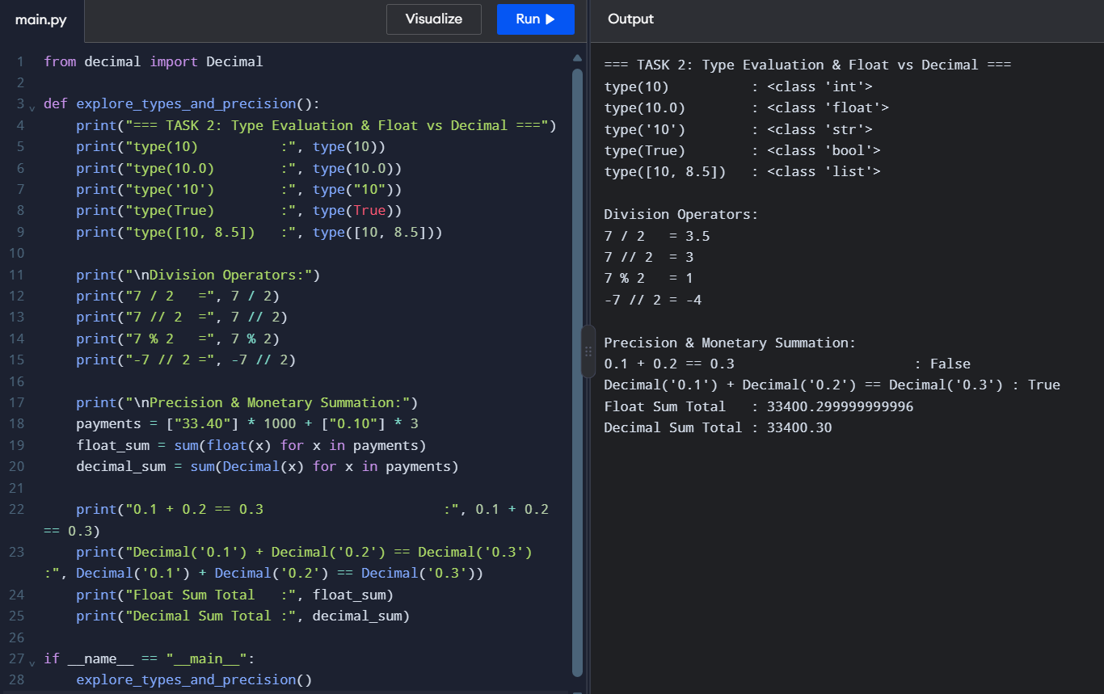
TASK 3 — Choose Variables and Name the Constants
1. Define constants for the base rate, fat adjustment, SNF adjustment, and applicable limits.
The following named constants are used in the milk-payment calculator:
BASE_RATE = 30.00
STANDARD_FAT = 3.5
STANDARD_SNF = 8.5
FAT_STEP_VALUE = 0.40
SNF_STEP_VALUE = 0.30
MIN_FAT = 2.0
MAX_FAT = 7.0
BASE_RATE represents the payment per litre at the standard fat and SNF values. FAT_STEP_VALUE and SNF_STEP_VALUE represent the rate adjustments for each 0.1% step in fat and SNF, respectively. MIN_FAT and MAX_FAT specify the permitted fat range.
Defining these values as constants makes the rate calculation easier to maintain and update.
2. Follow Python naming conventions, including UPPER_CASE for constants.
Python naming conventions recommend uppercase letters with underscores for constants. For example, BASE_RATE, FAT_STEP_VALUE and MAX_FAT follow this convention.
Ordinary variables and functions generally use lowercase letters with underscores, such as farmer_id, milk_litres and calculate_payment().
Following consistent naming conventions improves readability and helps programmers distinguish configuration values from variables that may change during execution.
3. Explain why Python does not enforce constants and how naming conventions help.
Python does not have a built-in mechanism that makes ordinary variables completely constant. A variable written in uppercase can still be reassigned.
For example:
BASE_RATE = 30.00
BASE_RATE = 32.00
Python permits this reassignment even though BASE_RATE is intended to be a constant.
Using uppercase names is a convention that communicates the programmer's intention not to change the value during normal execution. It reduces accidental modifications and makes the program easier for other developers to understand.
4. Demonstrate dynamic typing by assigning an integer and then a string to the same variable.
Python supports dynamic typing, meaning that a variable can refer to values of different data types during execution.
Example:
val = 100
print(val, type(val))
val = "One Hundred Litres"
print(val, type(val))
Output:
100 <class 'int'>
One Hundred Litres <class 'str'>
Initially, val refers to an integer. Later, it refers to a string. Python allows this without requiring the programmer to declare the variable's type in advance.
5. Demonstrate multiple assignment and swapping using a, b = b, a.
Python allows multiple assignment, which can be used to swap two variables without a temporary variable.
Example:
a, b = 10, 20
print("Before Swap:", a, b)
a, b = b, a
print("After Swap:", a, b)
Output:
Before Swap: 10 20
After Swap: 20 10
Python evaluates the values on the right-hand side before assigning them to the variables. Therefore, the original values are exchanged correctly.
6. Additional Question — Alternative Design and Complexity
Question: Compare using magic numbers, named constants and a dictionary to store rates. Explain the effort required to update rates, the number of places that may need modification, and whether these alternatives significantly change running time or memory usage.
Answer:
Method 1: Using magic numbers
Magic numbers are fixed values written directly inside expressions.
Example:
rate = 30.00 + fat_steps * 0.40 + snf_steps * 0.30
This approach is simple for small programs. However, if the rates change, the programmer must find and modify every expression containing the old values. Missing one occurrence may cause inconsistent calculations.
Method 2: Using named constants
Named constants store the values separately from the calculation.
Example:
BASE_RATE = 30.00
FAT_STEP_VALUE = 0.40
SNF_STEP_VALUE = 0.30
rate = BASE_RATE + fat_steps * FAT_STEP_VALUE + snf_steps * SNF_STEP_VALUE
When a rate changes, the programmer generally needs to modify only the relevant constant definition. This reduces maintenance effort and makes the calculation easier to understand.
Method 3: Using a dictionary
A dictionary stores related rates under meaningful keys.
Example:
RATE_CARD = {
"base": 30.00,
"fat": 0.40,
"snf": 0.30
}
rate = (
RATE_CARD["base"]
+ fat_steps * RATE_CARD["fat"]
+ snf_steps * RATE_CARD["snf"]
)
This approach groups related configuration values in one structure. It is useful when the program contains many rates or needs to load different rate cards.
Source Code
BASE_RATE = 30.00
FAT_STEP_VALUE = 0.40
SNF_STEP_VALUE = 0.30
def demonstrate_variables():
print("=== TASK 3: Constants & Dynamic Typing ===")
print(f"Constants Defined: BASE_RATE={BASE_RATE}, FAT_STEP={FAT_STEP_VALUE}, SNF_STEP={SNF_STEP_VALUE}")
val = 100
print(f"val = {val} | type = {type(val)}")
val = "One Hundred Litres"
print(f"val = '{val}' | type = {type(val)}")
a, b = 10, 20
print(f"Before Swap: a={a}, b={b}")
a, b = b, a
print(f"After Swap : a={a}, b={b}")
if __name__ == "__main__":
demonstrate_variables()

Execution Evidence Screenshot
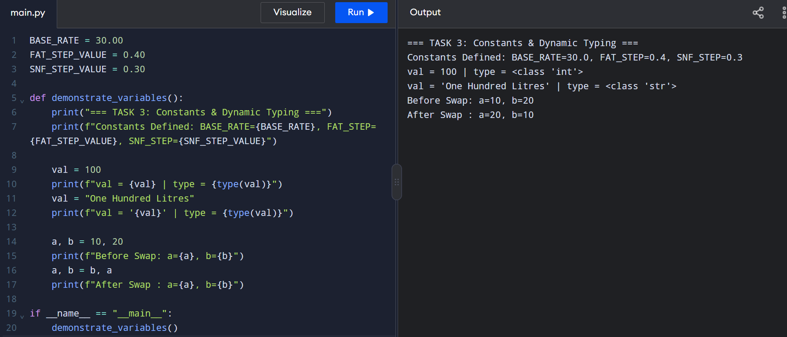
TASK 4 — Write Correct Expressions
1. Calculate the number of 0.1% fat steps relative to 3.5%.
The number of fat steps is calculated by subtracting the standard fat percentage from the measured fat percentage and dividing the difference by 0.1.
Expression:
fat_steps = round((fat - 3.5) / 0.1)
For a fat percentage of 4.2%:
[
\text{Fat steps} = \frac{4.2-3.5}{0.1} = 7
]
Therefore, the fat step count is 7.
2. Calculate the number of 0.1% SNF steps relative to 8.5%.
The number of SNF steps is calculated by subtracting the standard SNF percentage from the measured SNF percentage and dividing the difference by 0.1.
Expression:
snf_steps = round((snf - 8.5) / 0.1)
For an SNF percentage of 8.7%:
[
\text{SNF steps} = \frac{8.7-8.5}{0.1} = 2
]
Therefore, the SNF step count is 2.
3. Calculate the rate per litre and the payment amount.
The base rate is ₹30.00 per litre. Each fat step changes the rate by ₹0.40, and each SNF step changes it by ₹0.30.
Rate formula:
[
\text{Rate} = 30 + (\text{fat steps}\times0.40) + (\text{SNF steps}\times0.30)
]
Python expressions:
rate = 30.00 + fat_steps * 0.40 + snf_steps * 0.30
payment = litres * rate
For fat = 4.2%, SNF = 8.7%, and milk quantity = 8.5 litres:
- Fat steps = 7
- SNF steps = 2
[
\text{Rate} = 30 + (7\times0.40) + (2\times0.30)
]
[
\text{Rate} = 30 + 2.80 + 0.60 = ₹33.40
]
[
\text{Payment} = 8.5\times33.40 = ₹283.90
]
Therefore, the rate is ₹33.40 per litre, and the payment is ₹283.90.
4. Explain operator precedence and associativity, including exponentiation (**) and unary minus.
Operator precedence determines the order in which Python evaluates operators in an expression. Parentheses can be used to make the intended order clear.
For example:
result = 2 + 3 * 4
print(result)
Output:
14
Multiplication is evaluated before addition.
Exponentiation (**) has higher precedence than unary minus in expressions such as -2 ** 2.
print(-2 ** 2)
print((-2) ** 2)
Output:
-4
4
In the first expression, Python calculates 2 ** 2 first and then applies the negative sign. In the second expression, the parentheses make -2 the base, so its square is positive.
Exponentiation is right-associative:
print(2 ** 3 ** 2)
Output:
512
Python evaluates this as 2 ** (3 ** 2), giving 2 ** 9 = 512.
Understanding precedence and associativity helps prevent mistakes in rate and payment calculations.
5. Demonstrate why (4.2 - 3.5) / 0.1 may produce 7.000000000000001 and how round() can help.
Python's float type represents numbers using binary floating-point arithmetic. Some decimal values cannot be represented exactly in binary, which can cause small precision differences.
Example:
fat_steps_raw = (4.2 - 3.5) / 0.1
print(fat_steps_raw)
print(round(fat_steps_raw))
A possible output is:
7.000000000000001
7
The raw result contains a tiny floating-point error, but round() converts the value to the intended whole step count.
Similarly, the raw result for fat = 3.1% may be close to -3.9999999999999964 instead of exactly -4.0.
Therefore, rounding is useful when converting measured percentages into discrete 0.1% steps. The program should apply a consistent rounding rule, especially for values exactly halfway between steps.
6. Compare round(), int() and math.floor() for negative values.
These functions behave differently for negative numbers.
Example:
import math
value = -3.5
print(round(value))
print(int(value))
print(math.floor(value))
Output:
-4
-3
-4
- round() rounds to the nearest integer. Python uses ties-to-even rounding for exact halfway cases.
- int() removes the fractional part by truncating towards zero.
- math.floor() returns the greatest integer less than or equal to the value, rounding towards negative infinity.
For example, int(-3.9) returns -3, whereas math.floor(-3.9) returns -4.
For the milk calculator, int() should not be used directly to calculate negative step counts because truncation towards zero can produce an incorrect result. round() is appropriate when the intended rule is to select the nearest whole step.
7. Explain comparison chaining using 2.0 <= fat <= 7.0 and the use of Boolean operators.
Python supports comparison chaining, allowing two comparisons to be combined in one expression.
Example:
fat = 4.2
valid_fat = 2.0 <= fat <= 7.0
print(valid_fat)
Output:
True
The expression is equivalent to:
2.0 <= fat and fat <= 7.0
It checks whether the fat percentage is at least 2.0% and at most 7.0%. Both conditions must be true for the result to be True.
Boolean operators include:
- and: Returns True when both conditions are true.
- or: Returns True when at least one condition is true.
- not: Reverses a Boolean result.
For example:
valid_fat = 2.0 <= fat <= 7.0
valid_litres = litres >= 0
valid_record = valid_fat and valid_litres
This approach helps validate the milk fat percentage and quantity before calculating the payment.
8. Additional Question — Alternative Design and Complexity
Question: Compare using round(), int() and math.floor() to calculate fat steps for fat values of 4.2% and 3.1%. Show the resulting step counts and rate calculations, explain any differences, and state the time and space complexity of each approach.
Answer:
The standard fat percentage is 3.5%, and each step represents a difference of 0.1%.
The raw step calculation is:
fat_difference = (fat - 3.5) / 0.1
Case 1: Fat = 4.2%
[
(4.2-3.5)/0.1 = 7.0
]
Method | Step count
round(7.0) | 7
int(7.0) | 7
math.floor(7.0) | 7
Using 7 fat steps and assuming SNF = 8.5%, the rate is:
[
30+(7\times0.40)=₹32.80
]
All three methods produce the same result for this positive whole-number step count.

Case 2: Fat = 3.1%
[
(3.1-3.5)/0.1 = -4.0
]
Method | Step count
round(-4.0) | -4
int(-4.0) | -4
math.floor(-4.0) | -4
Using -4 fat steps and assuming SNF = 8.5%, the rate is:
[
30+(-4\times0.40)=₹28.40
]
All three methods produce the same result for this negative whole-number step count.
Important difference:
The methods differ when the raw step value is not a whole number. For example, if the raw value is -3.5, round(-3.5) returns -4, int(-3.5) returns -3, and math.floor(-3.5) returns -4.
Therefore, the correct method depends on the intended business rule. Since the calculator uses the nearest whole 0.1% step, round() is the most appropriate of these three methods, provided its rounding behaviour is understood.
Time and space complexity:
Each method performs a fixed number of arithmetic or conversion operations. Therefore, each takes O(1) time and O(1) additional space per calculation.
Source Code
import math
def evaluate_expressions():
print("=== TASK 4: Rounding Functions & Precedence ===")
fat_diff_pos = (4.2 - 3.5) / 0.1
print("Fat 4.2% relative step (0.7 / 0.1 = 7.0):")
print("round() :", round(fat_diff_pos))
print("int() :", int(fat_diff_pos))
print("math.floor():", math.floor(fat_diff_pos))
fat_diff_neg = (3.1 - 3.5) / 0.1
print("\nFat 3.1% relative step (-0.4 / 0.1 = -4.0):")
print("round() :", round(fat_diff_neg))
print("int() :", int(fat_diff_neg))
print("math.floor():", math.floor(fat_diff_neg))
print("\nPrecedence Demonstration:")
print("-2 ** 2 =", -2 ** 2)
print("(-2) ** 2 =", (-2) ** 2)
if __name__ == "__main__":
evaluate_expressions()
Execution Evidence Screenshot
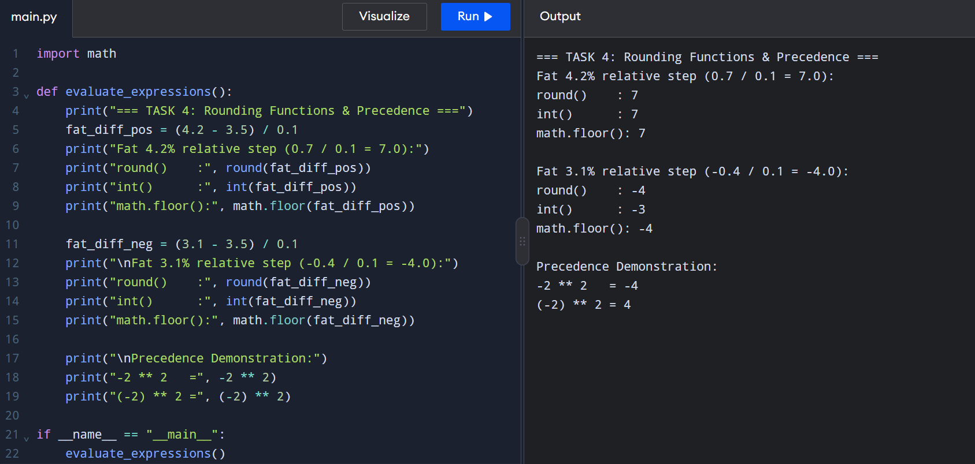
TASK 5 — Read Input and Convert Types
1. Explain why input() returns a string.
In Python, the input() function reads the user's entry and returns it as a string (str), even when the user enters a number.
For example:
age = input("Enter age: ")
print(type(age))
If the user enters 20, the output is:
<class 'str'>
The input must be converted into the appropriate data type before performing numerical calculations. For example, int() converts suitable input into an integer, while float() converts suitable input into a floating-point number.
2. Demonstrate converting input into integers and floating-point values using int() and float().
The int() function converts a valid whole-number string into an integer. The float() function converts a valid numerical string into a floating-point number.
Example:
quantity = int("10")
fat = float("4.2")
print(quantity, type(quantity))
print(fat, type(fat))
Output:
10 <class 'int'>
4.2 <class 'float'>
Integer conversion is suitable for values that must be whole numbers, such as a count of records. Floating-point conversion can represent quantities and percentages containing decimal places.
Invalid strings cannot be converted directly. For example, int("8.5") raises a ValueError because "8.5" is not a valid integer string.
3. Handle invalid inputs such as "8,5" and "eight".
The strings "8,5" and "eight" cannot be converted directly into Python floating-point numbers using float().
Example:
values = ["8,5", "eight"]
for value in values:
try:
number = float(value)
print(number)
except ValueError:
print("Invalid numerical input:", value)
Output:
Invalid numerical input: 8,5
Invalid numerical input: eight
The string "8,5" uses a comma as a decimal separator, whereas Python's standard float() conversion expects a decimal point, as in "8.5". The string "eight" contains words rather than a numerical representation.
The program should display an error message and request valid input instead of terminating unexpectedly.
4. Explain how to validate input before or during conversion.
Input can be validated before conversion by checking whether the entered value follows the expected format. For example, a program can check whether a string is empty before attempting conversion.
However, string methods such as isdigit() are limited. For example, "8.5".isdigit() returns False, even though "8.5" is a valid floating-point number.
Another approach is to convert the value inside a try/except block and then check its permitted range.
For example:
try:
litres = float(input("Enter litres: "))
if litres < 0:
print("Litres cannot be negative.")
else:
print(f"Litres: {litres:.2f}")
except ValueError:
print("Please enter a valid number.")
This method checks both numerical validity and the business rule that milk quantity cannot be negative.
5. Use try and except ValueError to handle invalid numerical input.
A try block contains the conversion that may fail. If the input cannot be converted, Python raises a ValueError, which can be handled by the except block.
Example:
def parse_input(input_val):
try:
value = float(input_val)
return f"Successfully parsed float: {value:.2f}"
except ValueError:
return f"ValueError: '{input_val}' cannot be converted to float."
print(parse_input("15.5"))
print(parse_input("abc"))
Output:
Successfully parsed float: 15.50
ValueError: 'abc' cannot be converted to float.
Exception handling prevents invalid numerical input from terminating the program unexpectedly. The function returns an appropriate message for both valid and invalid entries.
6. Format the output neatly using f-strings, including width and precision.
An f-string allows variables and expressions to be inserted directly into a string. Formatting options control the width and number of decimal places displayed.
Example:
amount = 283.9
print(f"Payment: ₹{amount:.2f}")
print(f"Payment: ₹{amount:10.2f}")
Output:
Payment: ₹283.90
Payment: ₹283.90
In {amount:.2f}, .2f displays the value to two decimal places. In {amount:10.2f}, the number occupies a minimum width of ten characters and is right-aligned by default.
This formatting is useful for displaying milk rates and payment amounts clearly and consistently.
7. Additional Question — Alternative Design and Complexity
Question: Compare validating input with string methods before conversion against converting the input inside a try/except ValueError block. Explain how each approach handles "8,5", " 8.5 " and "eight", and compare their time complexity per entry.
Answer:
Method 1: Validate using string methods before conversion
String methods such as strip(), isdigit() and replace() can be used to inspect or prepare input before conversion.
For example, strip() removes leading and trailing whitespace. However, isdigit() does not accept decimal points or negative signs, so it is not sufficient by itself to validate general numerical input.
- "8,5": float("8,5") fails because the input uses a comma as the decimal separator.
- " 8.5 ": The whitespace can be removed using strip(), producing "8.5", which can be converted successfully.
- "eight": String checks can identify that this is not a standard numerical representation.
Method 2: Convert inside a try/except ValueError block
This approach attempts the conversion directly and handles invalid values using exception handling.
Example:
values = ["8,5", " 8.5 ", "eight"]
for value in values:
try:
number = float(value)
print(f"{value!r} -> {number:.2f}")
except ValueError:
print(f"{value!r} -> Invalid input")
Output:
'8,5' -> Invalid input
' 8.5 ' -> 8.50
'eight' -> Invalid input
Python's float() accepts leading and trailing whitespace, so " 8.5 " converts successfully without explicitly calling strip().
Source Code
def parse_and_format_input(input_val):
try:
val = float(input_val)
print(f"Input: {input_val} -> Successfully parsed: {val:.2f}")
except ValueError:
print(f"Input: {input_val} -> Invalid input")

def test_inputs():
print("=== TASK 5: Input Conversion & Exception Handling ===")
sample_inputs = ["15.5", "4.2", "abc", "8,5", "10.0"]
for inp in sample_inputs:
parse_and_format_input(inp)

if __name__ == "__main__":
test_inputs()

Execution Evidence Screenshot
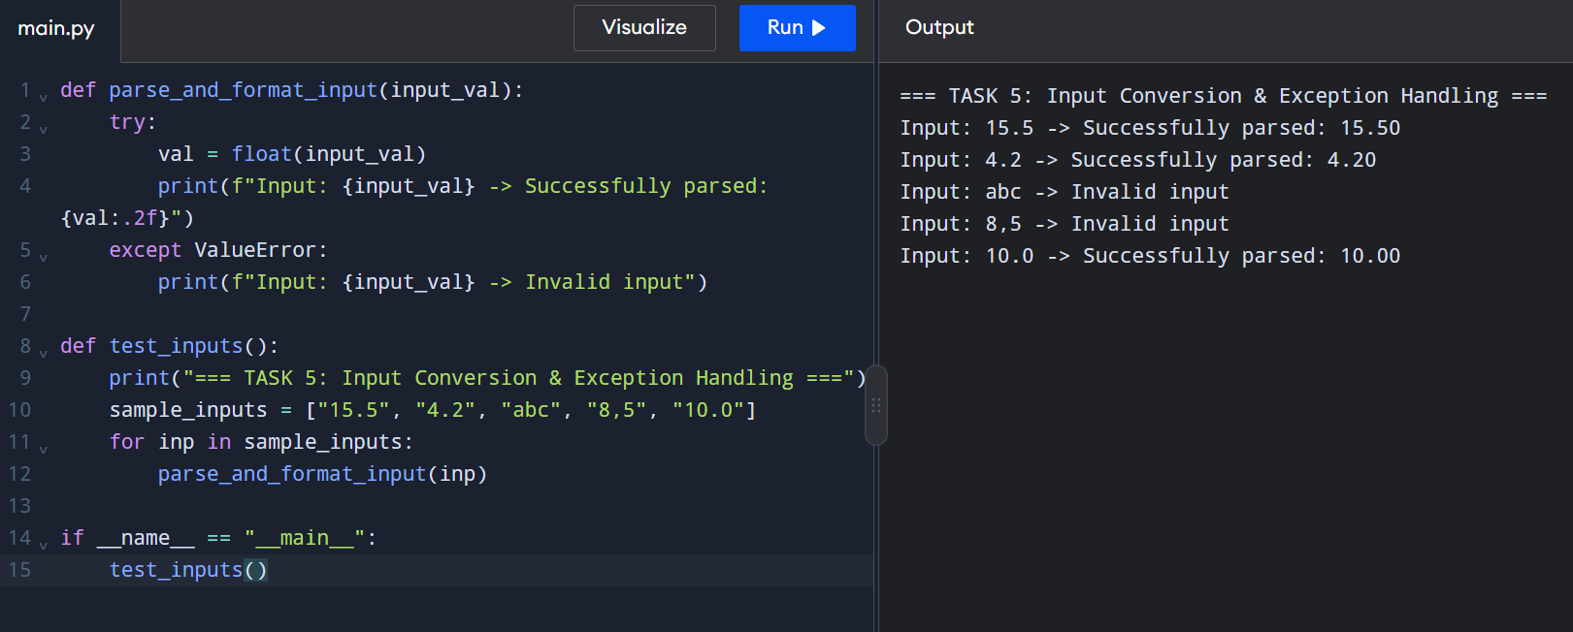
TASK 6 — Organise the Logic into Functions
1. Define suitable parameters and return values for each function.
The milk-payment calculator can be divided into three reusable functions.
a) rate_per_litre()
This function accepts fat and SNF percentages and returns the calculated rate per litre.
def rate_per_litre(fat, snf):
fat_steps = round((fat - 3.5) / 0.1)
snf_steps = round((snf - 8.5) / 0.1)
return 30.00 + fat_steps * 0.40 + snf_steps * 0.30
b) payout()
This function accepts the milk quantity, fat percentage and SNF percentage. It calls rate_per_litre() and returns the payment amount.
def payout(litres, fat, snf):
rate = rate_per_litre(fat, snf)
return litres * rate

c) ten_day_total()
This function accepts a collection of payment amounts and returns their total.
def ten_day_total(payments):
return sum(payments)
These functions separate rate calculation, individual payment calculation and total calculation. This makes the program easier to test, reuse and maintain.
2. Explain the difference between returning a value and printing it.
The return statement sends a result back to the part of the program that called the function. The returned value can be stored in a variable or used in another calculation.
The print() function displays information on the screen but does not return the displayed value as the function's result.
Example:
def add(a, b):
return a + b
result = add(10, 20)
print(result)
Output:
30
If the function used print(a + b) instead of return a + b, the result would be displayed but could not be directly assigned to result as the calculated sum.
Therefore, return is more suitable for the milk-payment functions because their results must be reused in further calculations.
3. Explain local and global variables.
A local variable is created inside a function and is normally accessible only within that function.
A global variable is defined outside functions and can be read by functions in the same module.
Example:
BASE_RATE = 30.00

def calculate_rate():
fat_steps = 2
return BASE_RATE + fat_steps * 0.40
print(calculate_rate())
Output:
30.8
Here, BASE_RATE is a global variable, while fat_steps is a local variable.
Local variables help keep calculations independent and reduce unintended changes elsewhere in the program. Global constants are useful for sharing fixed rate values across several functions.
4. Explain why rate constants can be read inside functions but should not be modified unnecessarily.
Rate constants such as BASE_RATE, FAT_STEP_VALUE and SNF_STEP_VALUE can be read inside functions without declaring them as global.
For example:
BASE_RATE = 30.00
def calculate_rate():
return BASE_RATE
This works because the function only reads the global value.
However, changing a global variable inside a function can make the program harder to understand and may affect other calculations. Python requires the global keyword when assigning to a global variable from inside a function.
For example:
BASE_RATE = 30.00
def update_rate():
global BASE_RATE
BASE_RATE = 32.00
Python permits this, but modifying rate constants unnecessarily is not recommended. Keeping the rate values unchanged during calculations makes the program more predictable and easier to maintain.
5. Add a docstring describing the purpose of every function.
A docstring is a string written immediately after a function definition. It describes the purpose of the function and may explain its parameters and return value.
Example:
def rate_per_litre(fat, snf):
fat_steps = round((fat - 3.5) / 0.1)
snf_steps = round((snf - 8.5) / 0.1)
return 30.00 + fat_steps * 0.40 + snf_steps * 0.30
def payout(litres, fat, snf):
rate = rate_per_litre(fat, snf)
return litres * rate
def ten_day_total(payments):
return sum(payments)
The docstrings explain what each function does, making the program easier for other developers to understand and use.
6. Additional Question — Alternative Design and Complexity
Question: Compare implementing the calculator as one long script, using reusable functions, and using lambda expressions where appropriate. Discuss code reuse, repeated logic, maintainability and the effect of function-call overhead when processing n entries.
Answer:
Method 1: One long script
A single long script contains all input handling, rate calculations, payment calculations and total calculations in one block.
This approach may be suitable for a very small program, but it becomes difficult to read and maintain as the program grows. Repeated calculations may be copied in several places, increasing the risk of errors when rate rules change.
Processing n entries requires O(n) time if each entry is processed once. The total complexity depends on how the records and results are stored.
Method 2: Reusable functions
Reusable functions divide the program into smaller units, such as rate_per_litre(), payout() and ten_day_total().
This reduces repeated logic and allows each function to be tested independently. If a rate formula changes, it can be updated in one function rather than in multiple places.
Processing n entries still requires O(n) time. Function calls introduce a small additional runtime cost, but this is usually outweighed by the improvements in readability, reuse and maintenance.
Method 3: Lambda expressions
A lambda expression creates a small anonymous function. It is suitable for simple operations.
Example:
payout = lambda litres, rate: litres * rate
The expression calculates a payment by multiplying litres by the rate. However, a named function is generally clearer when the calculation needs documentation, validation or multiple steps.
Lambda expressions do not automatically improve performance. They still involve function-call overhead and are less suitable for complex payment calculations.
Source Code
def rate_per_litre(fat, snf):
fat_steps = round((fat - 3.5) / 0.1)
snf_steps = round((snf - 8.5) / 0.1)
return round(30.00 + (fat_steps * 0.40) + (snf_steps * 0.30), 2)
def payout(litres, fat, snf):
return round(litres * rate_per_litre(fat, snf), 2)
def ten_day_total(entries):
return round(sum(payout(l, f, s) for l, f, s in entries), 2)
if __name__ == "__main__":
print("=== TASK 6: Modular Functions Verification ===")
sample_entries = [(10.0, 3.5, 8.5), (8.5, 4.2, 8.7), (12.0, 3.1, 8.3)]
for l, f, s in sample_entries:
print(f"Entry {l}L, {f}% fat, {s}% snf -> Rate: Rs.{rate_per_litre(f, s)} | Payout: Rs.{payout(l, f, s)}")
print("10-Day Total Payout for Farmer:", ten_day_total(sample_entries))

Execution Evidence Screenshot
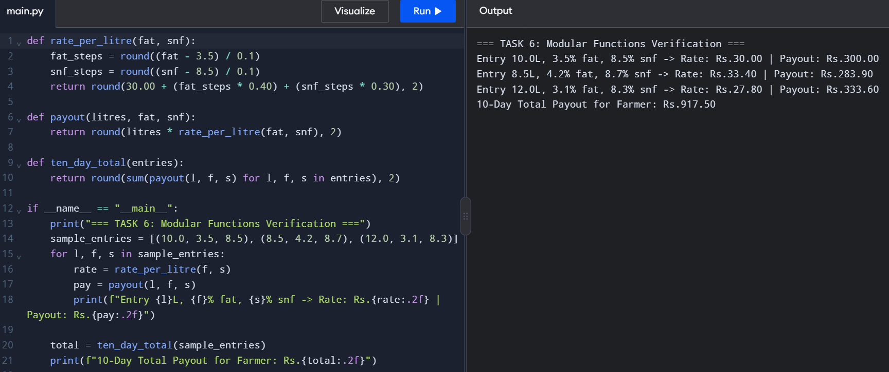
TASK 7 — Build and Use a Python Module
1. Explain the differences between import milkrate, from milkrate import payout, and import milkrate as mr.
Python provides different ways to import functions and variables from a module.
a) import milkrate
This imports the complete module. Its functions and variables are accessed using the module name.
Example:
import milkrate
amount = milkrate.payout(10, 3.5, 8.5)
print(amount)
b) from milkrate import payout
This imports only the specified function, allowing it to be called directly without writing the module name.
Example:
from milkrate import payout

amount = payout(10, 3.5, 8.5)
print(amount)
c) import milkrate as mr
This imports the module using the shorter alias mr.
Example:
import milkrate as mr
amount = mr.payout(10, 3.5, 8.5)
print(amount)
All three approaches allow the program to use the payment calculation. The main difference is how the imported function is referenced. Using a module name or alias also makes it clear where the function comes from.
2. Explain the purpose of if __name__ == "__main__":.
The statement if __name__ == "__main__": checks whether a Python file is being executed directly or imported into another file.
When milkrate.py is run directly, Python sets __name__ to "__main__". The demonstration code inside the condition executes.
When another script imports milkrate, its __name__ is set to "milkrate". Therefore, the demonstration code inside the condition does not execute.
Example:
def payout(litres, fat, snf):
return litres * 30.00
if __name__ == "__main__":
print(payout(10, 3.5, 8.5))
This allows the module to demonstrate its functions when run directly without automatically displaying the demonstration output when imported.
3. Describe what happens if demonstration code runs whenever the module is imported.
If demonstration code is written outside the if __name__ == "__main__": condition, it executes when the module is imported.
For example, importing milkrate could automatically print the demonstration table even if the importing program only needs the payout() function.
This can produce unwanted output and make the module difficult to reuse in other programs. It may also cause unnecessary calculations to run every time the module is imported for the first time.
Therefore, reusable functions should be defined at module level, while demonstration code should be placed inside the if __name__ == "__main__": condition.
4. Explain the use of standard modules such as math and decimal.
Python provides standard modules that contain useful functions and classes.
The math module:
The math module provides mathematical functions such as floor(), ceil() and sqrt().
Example:
import math
print(math.floor(4.8))
Output:
4
It is useful when mathematical operations are required in a program.
The decimal module:
The decimal module provides decimal arithmetic that can represent decimal monetary values exactly when constructed from strings.
Example:
from decimal import Decimal
amount = Decimal("33.40")
adjustment = Decimal("0.10")
print(amount + adjustment)
Output:
33.50
The decimal module is useful for financial calculations because ordinary floating-point numbers may contain small representation errors. A monetary application should also define an appropriate rounding policy.
5. Explain how Python searches for modules using the current directory and sys.path.
When a Python program imports a module, Python searches locations specified by its module search path, available through sys.path.
These locations typically include the script's directory, standard library locations and installed package directories. The exact search path depends on how Python is launched and configured.
For example, if milkrate.py and main.py are stored in the same directory, main.py can usually import the module using:
import milkrate
The search path can be inspected using:
import sys
print(sys.path)
If Python cannot find the module in the locations it searches, it raises a ModuleNotFoundError.
Keeping related project files in the same directory simplifies module imports for this assignment.
6. Explain why the demonstration table is not printed when milkrate is imported by another script.
The demonstration table is placed inside the condition:
if __name__ == "__main__":
When milkrate.py is executed directly, the condition is true, and the table is printed.
When another script imports milkrate, the module name is "milkrate" rather than "__main__". Therefore, the condition is false and the demonstration table is not printed.
The imported script can still call functions such as rate_per_litre() and payout(). This keeps the module reusable and prevents unwanted output.
7. Additional Question — Alternative Design and Complexity
Question: Compare importing shared functions from a module with copying the same functions into every script that needs them. Discuss maintainability, the effort required for rate revisions, the one-time cost of importing a module, and how Python caches imported modules in sys.modules.
Answer:
Method 1: Copying functions into every script
In this approach, each script contains its own copy of the rate and payment functions.
This may initially seem simple, but it duplicates code. If the milk-payment rates change, every copy must be found and updated. Missing one copy could cause different programs to calculate different payments.
Duplicated code therefore increases maintenance effort and the risk of inconsistent results.
Method 2: Importing shared functions from a module
In this approach, the rate and payment functions are stored in a single file named milkrate.py. Other scripts import and reuse those functions.
If the rate formula changes, it can be updated in the module and used by the scripts that import it. This improves code reuse, consistency and maintainability.
Python's module cache
Python stores imported modules in sys.modules. When a module has already been imported in the same Python interpreter, subsequent imports normally reuse the cached module rather than executing the module's code from the beginning again.
The initial import involves locating and loading the module, so it has some overhead. Reusing a cached module avoids repeating much of that work. However, calling the imported functions still has its normal execution cost.
Source Code
BASE_RATE = 30.00
FAT_STEP_VALUE = 0.40
SNF_STEP_VALUE = 0.30
def rate_per_litre(fat, snf):
fat_steps = round((fat - 3.5) / 0.1)
snf_steps = round((snf - 8.5) / 0.1)
rate = BASE_RATE + (fat_steps * FAT_STEP_VALUE) + (snf_steps * SNF_STEP_VALUE)
return round(rate, 2)
def payout(litres, fat, snf):
rate = rate_per_litre(fat, snf)
return round(litres * rate, 2)
if __name__ == "__main__":
print("--- Task 7: milkrate.py Execution Test ---")
for litres, fat, snf in [(10, 3.5, 8.5), (8.5, 4.2, 8.7), (12, 3.1, 8.3)]:
r = rate_per_litre(fat, snf)
p = payout(litres, fat, snf)
print(f"Litres: {litres:5.1f} L | Fat: {fat}% | SNF: {snf}% | Rate: Rs.{r:6.2f} | Payout: Rs.{p:8.2f}")

Execution Evidence Screenshot
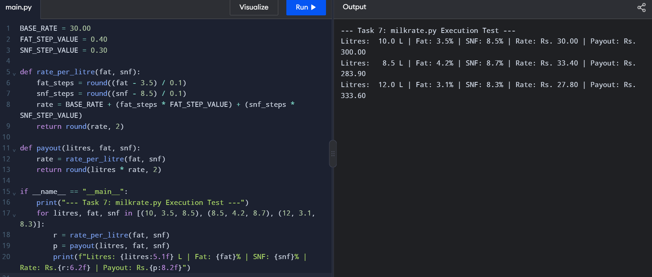
TASK 8 — Plan the Algorithm Before Coding
1. Explain the stages of algorithmic problem-solving: understand, plan, write, and test.
Algorithmic problem-solving involves four main stages.
Understand: Identify the inputs, outputs, requirements and validation rules. For the milk-payment calculator, the inputs include farmer ID, milk quantity, fat percentage, SNF percentage and shift. The outputs include the rate per litre, payment amount and ten-day total.
Plan: Develop the solution using an algorithm, pseudocode and a flowchart before writing the program.
Write: Convert the planned algorithm into Python code using variables, constants, conditions, loops and functions.
Test: Run the program with normal, boundary and invalid inputs. Compare the actual results with manually calculated expected results and correct any errors.
2. Write pseudocode for calculating one payment.
Pseudocode: Calculate One Milk Payment
BEGIN
INPUT farmer_id
INPUT litres
INPUT fat
INPUT snf
INPUT shift
IF farmer_id is empty OR shift is empty THEN
DISPLAY "Invalid farmer ID or shift"
STOP
END IF
IF litres < 0 THEN
DISPLAY "Invalid milk quantity"
STOP
END IF
IF fat < 2.0 OR fat > 7.0 THEN
DISPLAY "Invalid fat percentage"
STOP
END IF
IF snf < 0 THEN
DISPLAY "Invalid SNF percentage"
STOP
END IF
fat_steps = ROUND((fat - 3.5) / 0.1)
snf_steps = ROUND((snf - 8.5) / 0.1)
rate = 30.00 + (fat_steps * 0.40)
+ (snf_steps * 0.30)
payment = litres * rate

DISPLAY rate
DISPLAY payment
END
The algorithm first validates the inputs. It then calculates the fat and SNF steps, determines the rate per litre and calculates the payment.
Assumption: The calculation uses the nearest whole 0.1% step, with ₹30.00 as the base rate, ₹0.40 per fat step and ₹0.30 per SNF step.
3. Extend the pseudocode to calculate the ten-day total for one farmer.
Pseudocode: Calculate Ten-Day Total
BEGIN
total = 0
FOR day = 1 TO 10
INPUT farmer_id, litres, fat, snf, shift
VALIDATE all inputs
IF inputs are valid THEN
fat_steps = ROUND((fat - 3.5) / 0.1)
snf_steps = ROUND((snf - 8.5) / 0.1)
rate = 30.00 + (fat_steps * 0.40)
+ (snf_steps * 0.30)
payment = litres * rate
total = total + payment
DISPLAY rate
DISPLAY payment
ELSE
DISPLAY "Invalid entry; enter the data again"
REPEAT the current day
END IF
END FOR
DISPLAY "Ten-day total =", total
END
The algorithm processes ten valid entries for one farmer. Each payment is added to the running total. If an entry is invalid, the program requests the data again rather than including an invalid payment.
4. Draw a flowchart showing the validation and calculation of one entry.
The flowchart should follow this sequence:
Start → Input details → Validate inputs → Are inputs valid? → Calculate fat and SNF steps → Calculate rate → Calculate payment → Display results → End.
If the inputs are invalid, display an error message and request the data again.
Insert your Task 8 flowchart image here.
The flowchart visually represents the decision-making and calculation steps of the algorithm. The validation decision prevents invalid entries from being used in payment calculations.
5. Hand-trace the algorithm using three sample entries.
A hand trace shows how the algorithm processes sample data and calculates each payment.
Entry | Litres | Fat (%) | SNF (%) | Fat steps | SNF steps | Rate per litre (₹) | Payment (₹)
1 | 10.0 | 3.5 | 8.5 | 0 | 0 | 30.00 | 300.00
2 | 8.5 | 4.2 | 8.7 | 7 | 2 | 33.40 | 283.90
3 | 12.0 | 3.1 | 8.3 | -4 | -2 | 27.80 | 333.60
Total | 30.5 | — | — | — | — | — | 917.50
Calculations:
Entry 1:
Fat steps = (3.5 − 3.5) / 0.1 = 0
SNF steps = (8.5 − 8.5) / 0.1 = 0
Rate = ₹30.00 per litre
Payment = 10 × 30.00 = ₹300.00
Entry 2:
Fat steps = round((4.2 − 3.5) / 0.1) = 7
SNF steps = round((8.7 − 8.5) / 0.1) = 2
Rate = 30.00 + (7 × 0.40) + (2 × 0.30) = ₹33.40
Payment = 8.5 × 33.40 = ₹283.90
Entry 3:
Fat steps = round((3.1 − 3.5) / 0.1) = −4
SNF steps = round((8.3 − 8.5) / 0.1) = −2
Rate = 30.00 + (−4 × 0.40) + (−2 × 0.30) = ₹27.80
Payment = 12 × 27.80 = ₹333.60
Ten-day total for these three sample entries: ₹917.50.
This is the total of the three entries shown, not a complete ten-day total. The algorithm would continue processing entries until ten valid entries had been recorded.
6. Follow the SIMATS Engineering standard for algorithmic pseudocode.
The pseudocode uses a clear, structured format with BEGIN, END, INPUT, DISPLAY, IF, ELSE, FOR and assignment statements.
Each step is written in a logical order, with indentation used to show conditions and loops. Calculations are separated from input validation, and meaningful variable names such as fat_steps, snf_steps, rate, payment and total are used.
This structure makes the algorithm readable and easier to convert into Python code.
7. Additional Question — Alternative Design and Complexity
Question: Compare storing every entry in a list and calculating the total at the end with maintaining a running total while reading each entry. Explain time complexity and space complexity for n entries, and state when retaining individual entries is necessary.
Answer:
Method 1: Store every entry in a list
Each valid entry is stored in a list. After all entries have been collected, the program calculates the total by adding the payments.
- Time complexity: O(n) to process the entries and calculate the total.
- Space complexity: O(n), because all entries or payment records are stored.
- Advantage: Individual records can be reviewed, corrected, printed or analysed later.
- Disadvantage: More memory is required as the number of entries increases.
Method 2: Maintain a running total
The program calculates each payment and immediately adds it to a variable named total. It does not need to retain all payment records if only the final total is required.
Example:
total = 0.0
for payment in payments:
total += payment
print(f"Ten-day total: ₹{total:.2f}")
- Time complexity: O(n), because each payment is processed once.
- Additional space complexity: O(1), if only the running total and current entry are retained.
- Advantage: Uses less additional memory.
- Disadvantage: Individual entries cannot be reviewed later unless they are stored separately.
Algorithmic Flowchart Diagram
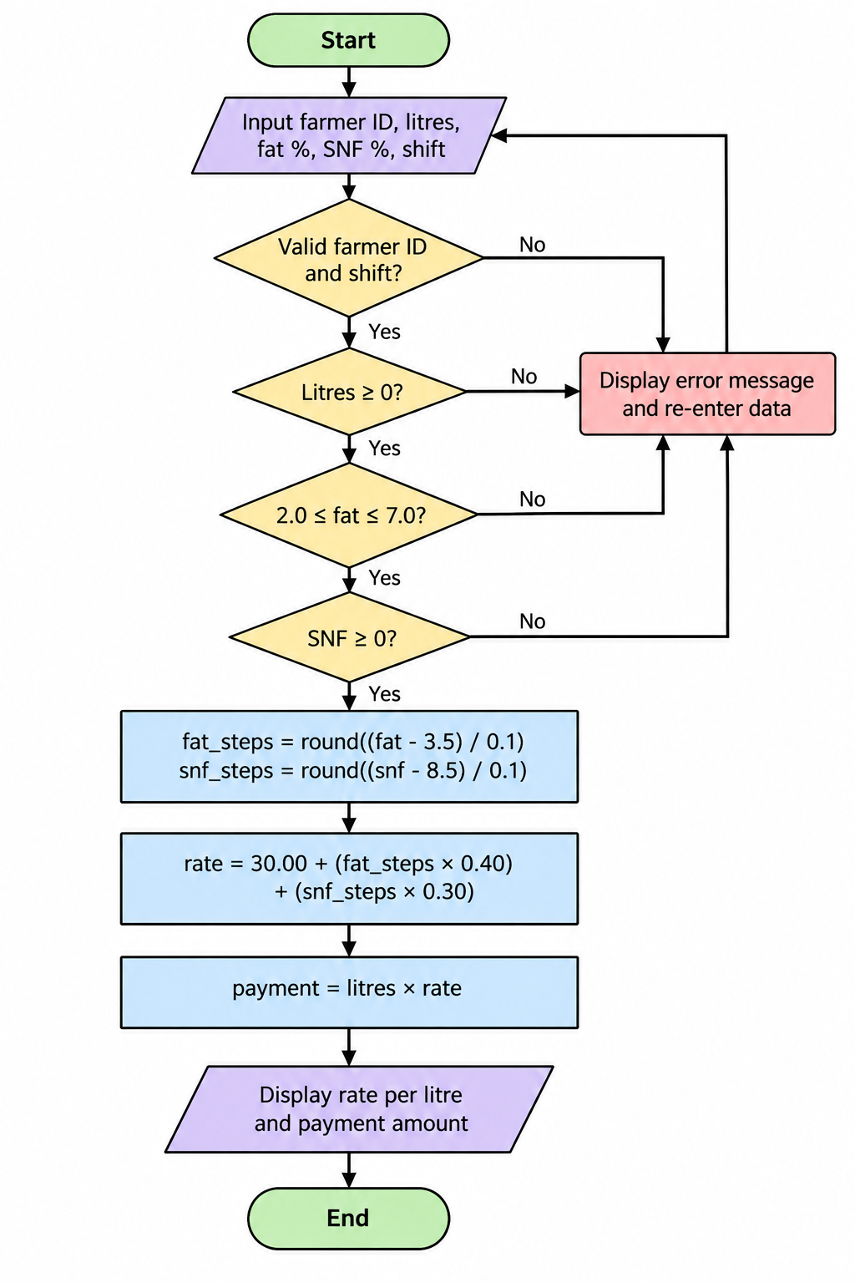

Source Code
def process_milk_collection(records):
print("=== TASK 8: Algorithm Processing Verification ===")
total_payout = 0.0
for rec in records:
farmer_id, litres, fat, snf = rec
if not (2.0 <= fat <= 7.0) or snf < 0 or litres < 0:
print(f"Farmer {farmer_id}: INVALID RECORD (Fat={fat}, SNF={snf}, Litres={litres}) -> Skipped")
continue
fat_steps = round((fat - 3.5) / 0.1)
snf_steps = round((snf - 8.5) / 0.1)
rate = 30.00 + (fat_steps * 0.40) + (snf_steps * 0.30)
pay = litres * rate
total_payout += pay
print(f"Farmer {farmer_id}: Valid Record ({litres}L) -> Rate: Rs.{rate:.2f}, Payout: Rs.{pay:.2f}")
return round(total_payout, 2)
if __name__ == "__main__":
data = [
("F001", 10.0, 3.5, 8.5),
("F002", 8.5, 4.2, 8.7),
("F003", 12.0, 1.5, 8.0),
("F004", 15.0, 4.5, 8.8)
]
tot = process_milk_collection(data)
print("Total Valid Collection Payout: Rs.", tot)

Execution Evidence Screenshot
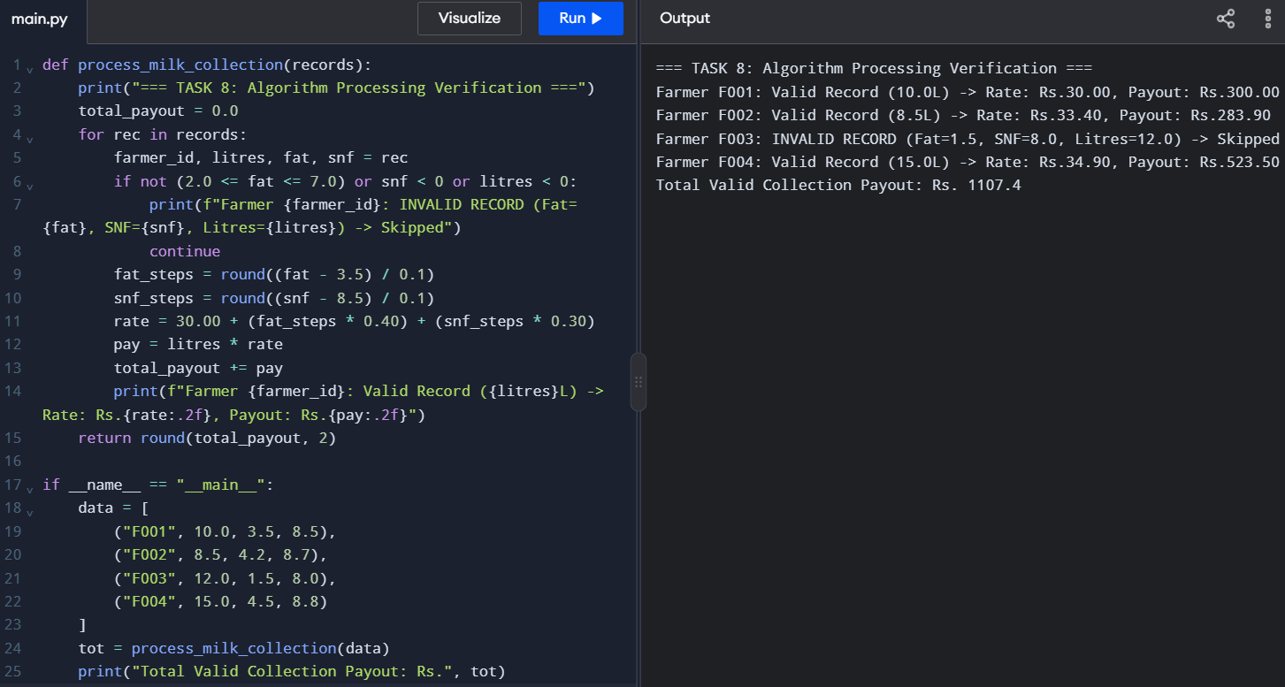
TASK 9 — Implement and Test the Calculator
1. Testing the Milk Payment Calculator
Testing verifies that the milk payment calculator produces correct results for valid inputs and handles invalid inputs properly. The program is tested using normal values, boundary values and incorrect entries.
Test Cases and Expected Results
The base rate is ₹30.00 per litre. Each 0.1% increase in fat changes the rate by ₹0.40, and each 0.1% increase in SNF changes the rate by ₹0.30.
Test No. | Test case | Input | Expected result | Status
1 | Fat and SNF above standard | 10 L, fat 4.2%, SNF 8.7% | Rate ₹33.40/L; payment ₹334.00 | Pass if matched
2 | Fat and SNF below standard | 10 L, fat 3.1%, SNF 8.3% | Rate ₹27.80/L; payment ₹278.00 | Pass if matched
3 | Standard values | 10 L, fat 3.5%, SNF 8.5% | Rate ₹30.00/L; payment ₹300.00 | Pass if matched
4 | Lowest allowed fat | 10 L, fat 2.0%, SNF 8.5% | Rate ₹24.00/L; payment ₹240.00 | Pass if matched
5 | Highest allowed fat | 10 L, fat 7.0%, SNF 8.5% | Rate ₹44.00/L; payment ₹440.00 | Pass if matched
6 | Invalid text input | Litres = abc | Display an error message; do not calculate payment | Pass if matched
7 | Negative milk quantity | Litres = -5 | Reject the quantity and display an error | Pass if matched
8 | Fat below allowed range | Fat = 1.9% | Reject the fat percentage | Pass if matched
9 | Fat above allowed range | Fat = 7.1% | Reject the fat percentage | Pass if matched
2. Manual Calculation of Five Entries
The following sample demonstrates how the payment total can be checked manually.
Entry | Litres | Fat (%) | SNF (%) | Rate per litre (₹) | Payment (₹)
1 | 10.0 | 3.5 | 8.5 | 30.00 | 300.00
2 | 8.5 | 4.2 | 8.7 | 33.40 | 283.90
3 | 12.0 | 3.1 | 8.3 | 27.80 | 333.60
4 | 10.0 | 4.0 | 8.5 | 32.00 | 320.00
5 | 8.0 | 3.5 | 8.7 | 30.60 | 244.80
Total | 48.5 | — | — | — | 1,482.30
Manual verification:
Total payment = ₹300.00 + ₹283.90 + ₹333.60 + ₹320.00 + ₹244.80
Total = ₹1,482.30
3. Additional Question — Manual Testing vs Automated Testing
Manual Testing
Manual testing involves entering test data, running the program and comparing the actual output with the expected result. It is useful for checking individual cases and understanding how the program behaves.
Advantages:
- Easy to perform for a small number of test cases.
- Helps identify incorrect output and validation errors.
- Requires little additional code.
Disadvantages:
- Repeating many tests takes time.
- Results may be recorded incorrectly.
- Every test must be repeated manually after code changes.

Automated Testing
Automated testing uses functions and assert statements to check whether the program produces the expected results.
Example:
def test_rate_per_litre():
assert rate_per_litre(3.5, 8.5) == 30.00
assert rate_per_litre(4.2, 8.7) == 33.40
assert rate_per_litre(3.1, 8.3) == 27.80
def test_payment():
assert payout(10, 3.5, 8.5) == 300.00
assert payout(8.5, 4.2, 8.7) == 283.90
test_rate_per_litre()
test_payment()
print("All tests passed!")
This example assumes that the functions rate_per_litre() and payout() have already been defined in the program.
Advantages:
- Runs multiple tests quickly.
- Repeats the same tests consistently.
- Helps detect errors after changes to the program.
Disadvantages:
- Test functions must be written correctly.
- Tests must be updated when the expected behaviour changes.

Complexity and Effort Comparison
Factor | Manual testing | Automated testing
Execution | Tests are performed manually | Tests run automatically
Initial effort | Usually low | Requires writing test code
Repeated testing | Takes more time | Fast and consistent
Reliability | Depends on the person performing the test | Repeatable when tests are correct
Time for n tests | Generally O(n) | Generally O(n) for n tests
After code changes | Repeat tests manually | Run the existing test suite again
Both methods may require O(n) time to execute n test cases. Automated testing usually saves effort when the same tests must be repeated frequently, although preparing the tests requires an initial investment of time.
Source Code
def rate_per_litre(fat, snf):
fat_steps = round((fat - 3.5) / 0.1)
snf_steps = round((snf - 8.5) / 0.1)
return round(30.00 + (fat_steps * 0.40) + (snf_steps * 0.30), 2)

def payout(litres, fat, snf):
return round(litres * rate_per_litre(fat, snf), 2)

def run_tests():
print("=== TASK 9: Automated Unit Test Suite Execution ===")
test_cases = [
("TC1: Normal Above", 10.0, 4.2, 8.7, 33.40, 334.00),
("TC2: Normal Below", 10.0, 3.1, 8.3, 27.80, 278.00),
("TC3: Exact Base", 10.0, 3.5, 8.5, 30.00, 300.00),
("TC4: Min Fat Boundary", 10.0, 2.0, 8.5, 24.00, 240.00),
("TC5: Max Fat Boundary", 10.0, 7.0, 8.5, 44.00, 440.00),
]

print(f"{'Test Case':<22} | {'Litres':<6} | {'Fat':<4} | {'SNF':<4} | {'Exp Rate':<8} | {'Act Rate':<8} | {'Status'}")
print("-" * 80)
all_pass = True
for name, l, f, s, exp_r, exp_p in test_cases:
act_r = rate_per_litre(f, s)
act_p = payout(l, f, s)
status = "PASS" if (act_r == exp_r and act_p == exp_p) else "FAIL"
if status == "FAIL":
all_pass = False
print(f"{name:<22} | {l:<6.1f} | {f:<4.1f} | {s:<4.1f} | {exp_r:<8.2f} | {act_r:<8.2f} | {status}")

print("-" * 80)
print("ALL TESTS PASSED SUCCESSFULLY!" if all_pass else "TEST SUITE FAILED!")

if __name__ == "__main__":
run_tests()

Execution Evidence Screenshot
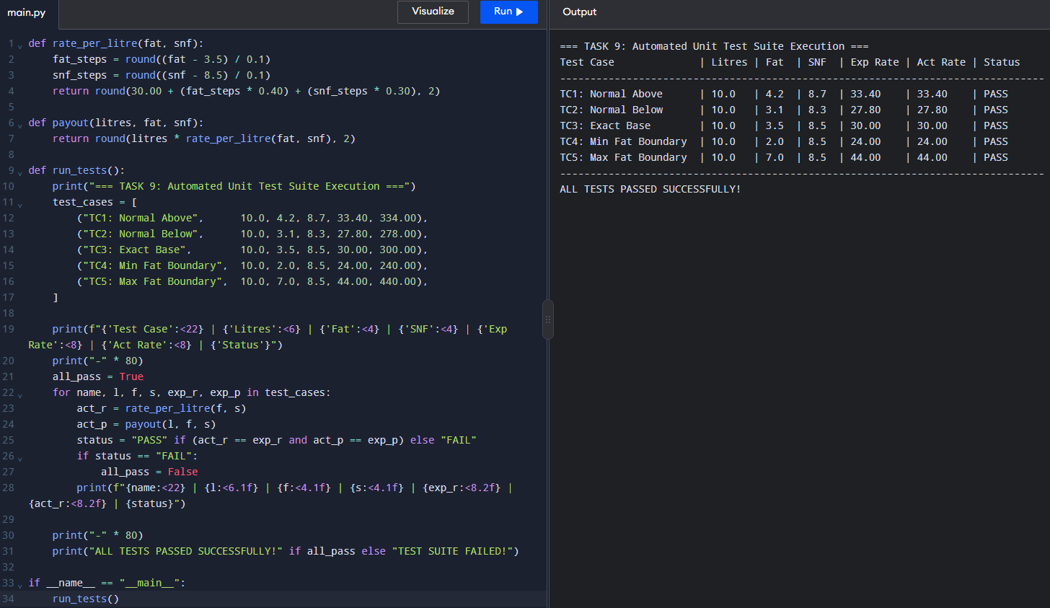
TASK 10 — Compare Expectations with Execution
1. Compare float and Decimal totals for 300, 6,000 and 150,000 payments.
Python provides different ways to represent monetary values. The float type stores numbers in binary floating-point format, which can introduce small precision errors. The Decimal type can represent decimal amounts such as ₹33.40 exactly when constructed from strings.
For this experiment, each payment is ₹33.40.
Expected totals:
- 300 payments = 300 × ₹33.40 = ₹10,020.00
- 6,000 payments = 6,000 × ₹33.40 = ₹200,400.00
- 150,000 payments = 150,000 × ₹33.40 = ₹5,010,000.00
The following table compares the expected totals with the results obtained using float and Decimal.
Number of payments | Expected total (₹) | Float total (₹) | Decimal total (₹)
300 | 10,020.00 | Record actual result | Record actual result
6,000 | 200,400.00 | Record actual result | Record actual result
150,000 | 5,010,000.00 | Record actual result | Record actual result
The float and Decimal totals should be compared with the expected values. Decimal arithmetic constructed from strings avoids the usual binary floating-point representation errors for these amounts.
2. Measure execution time using time.perf_counter().
The time.perf_counter() function measures elapsed time with high precision. The program records the time before and after each calculation and subtracts the two values to obtain the execution time.
Example:
import time
from decimal import Decimal
payment = "33.40"
for count in (300, 6000, 150000):
payments = [payment] * count
start = time.perf_counter()
float_total = sum(float(amount) for amount in payments)
float_time = time.perf_counter() - start
start = time.perf_counter()
decimal_total = sum(
(Decimal(amount) for amount in payments),
Decimal("0.00")
)
decimal_time = time.perf_counter() - start

print(f"Payments: {count}")
print(f"Float total: {float_total:.2f}")
print(f"Float time: {float_time:.6f} seconds")
print(f"Decimal total: {decimal_total:.2f}")
print(f"Decimal time: {decimal_time:.6f} seconds")
print()
Run the program on your computer and record the actual execution times. The timings may differ depending on the computer, Python version and system load.
3. Investigate whether rounding each payment or rounding only the final total produces the correct bank amount.
Rounding each payment means converting every individual payment to two decimal places before adding it to the total. Rounding only the final total means adding the unrounded values first and then rounding the sum.
For example, consider three payments of ₹10.005.
Rounding each payment first:
If each amount is rounded to ₹10.01 using a specified half-up rounding rule:
Total = ₹10.01 + ₹10.01 + ₹10.01 = ₹30.03
Rounding only the final total:
Unrounded total = ₹10.005 + ₹10.005 + ₹10.005 = ₹30.015
Rounded half-up to two decimal places = ₹30.02
The results differ by ₹0.01. Therefore, the rounding policy affects the final amount.
For a banking or payment system, the rounding method should follow the co-operative's accounting rules. The program should use a consistent policy and document whether individual payments or only the final total are rounded.
4. Explain the reasons for differences between expected and actual results.
Differences between expected and actual results may occur because of:
- Floating-point precision: Some decimal fractions cannot be represented exactly using binary floating-point numbers.
- Rounding policy: Rounding every payment may produce a different total from rounding only the final sum.
- Data conversion: Converting a decimal string to float can introduce a small representation difference.
- Execution environment: Execution times vary depending on hardware, background processes and system load.
- Implementation differences: Different calculation orders or rounding methods can produce different results.
Decimal arithmetic created from strings is suitable for financial calculations when exact decimal representation is required. However, the rounding policy must still be defined.
5. Record the totals and execution times in a table.
After running the program, enter your actual results in the table below.
Number of payments | Expected total (₹) | Float total (₹) | Decimal total (₹) | Float time (seconds) | Decimal time (seconds)
300 | 10,020.00 | Enter result | Enter result | Enter time | Enter time
6,000 | 200,400.00 | Enter result | Enter result | Enter time | Enter time
150,000 | 5,010,000.00 | Enter result | Enter result | Enter time | Enter time
Observation: The expected total increases in direct proportion to the number of payments. Both methods should produce the same displayed monetary total for these identical ₹33.40 payments, although the underlying float value may contain a small representation error. Decimal calculations are generally slower than float calculations, but the actual difference must be measured.
6. Additional Question — Alternative Design and Complexity
Question: Suppose the rate for each (fat, snf) pair is calculated once and stored in a dictionary instead of being recalculated for every entry. Explain how the rate table works, compare the time per entry for dictionary lookup and recalculation, and discuss the additional space required for k distinct pairs.
Answer:
A rate table stores the calculated rate for each unique combination of fat and SNF percentages in a Python dictionary. The pair (fat, snf) is used as the key, and the calculated rate is stored as the value.
Example:
rate_table = {
(3.5, 8.5): 30.00,
(4.2, 8.7): 33.40,
(3.1, 8.3): 27.80
}
rate = rate_table[(4.2, 8.7)]
print(f"Rate per litre: ₹{rate:.2f}")
When an entry has a fat and SNF combination already in the dictionary, the program retrieves its rate instead of recalculating it.
Comparison of the two approaches
Method 1: Recalculate the rate for every entry
The program calculates the fat steps, SNF steps and rate for every milk entry.
- Time per entry: O(1), because the formula uses a fixed number of arithmetic operations.
- Total time for n entries: O(n).
- Additional space: O(1), if no rate table is stored.
Method 2: Use a dictionary rate table
The program calculates rates for distinct combinations once and stores them. Later entries retrieve the rate from the dictionary.
- Average lookup time per entry: O(1).
- Initial calculation and construction: O(k), where k is the number of distinct (fat, snf) pairs.
- Total average time: O(n + k).
- Additional space: O(k), because the dictionary stores k distinct combinations.
Comparison table
Factor | Recalculate rate | Dictionary rate table
Rate calculation | Per entry | Once per distinct pair
Average lookup time | Not applicable | O(1)
Total time for n entries | O(n) | O(n + k)
Additional space | O(1) | O(k)
Best suited for | Simple calculations | Repeated fat and SNF combinations
Source Code
import time
from decimal import Decimal

def rate_per_litre(fat, snf):
fat_steps = round((fat - 3.5) / 0.1)
snf_steps = round((snf - 8.5) / 0.1)
return round(30.00 + (fat_steps * 0.40) + (snf_steps * 0.30), 2)

def payout(litres, fat, snf):
return round(litres * rate_per_litre(fat, snf), 2)

def run_benchmark():
print("=== TASK 10: Scaling Benchmark for District Milk Union ===")
counts = [300, 6000, 150000]
print(f"{'Farmers':<10} | {'Float Total (Rs)':<18} | {'Decimal Total (Rs)':<20} | {'Time Float (s)':<15} | {'Time Dec (s)':<15}")
print("-" * 85)

for n in counts:
t0 = time.perf_counter()
f_total = sum(payout(10.0, 4.2, 8.7) for _ in range(n))
t1 = time.perf_counter()
time_float = t1 - t0

t0 = time.perf_counter()
d_rate = Decimal('33.40')
d_payout = Decimal('10.0') * d_rate
d_total = sum(d_payout for _ in range(n))
t2 = time.perf_counter()
time_dec = t2 - t0

print(f"{n:<10d} | {f_total:<18.2f} | {float(d_total):<20.2f} | {time_float:<15.6f} | {time_dec:<15.6f}")

if __name__ == "__main__":
run_benchmark()

Execution Evidence Screenshot
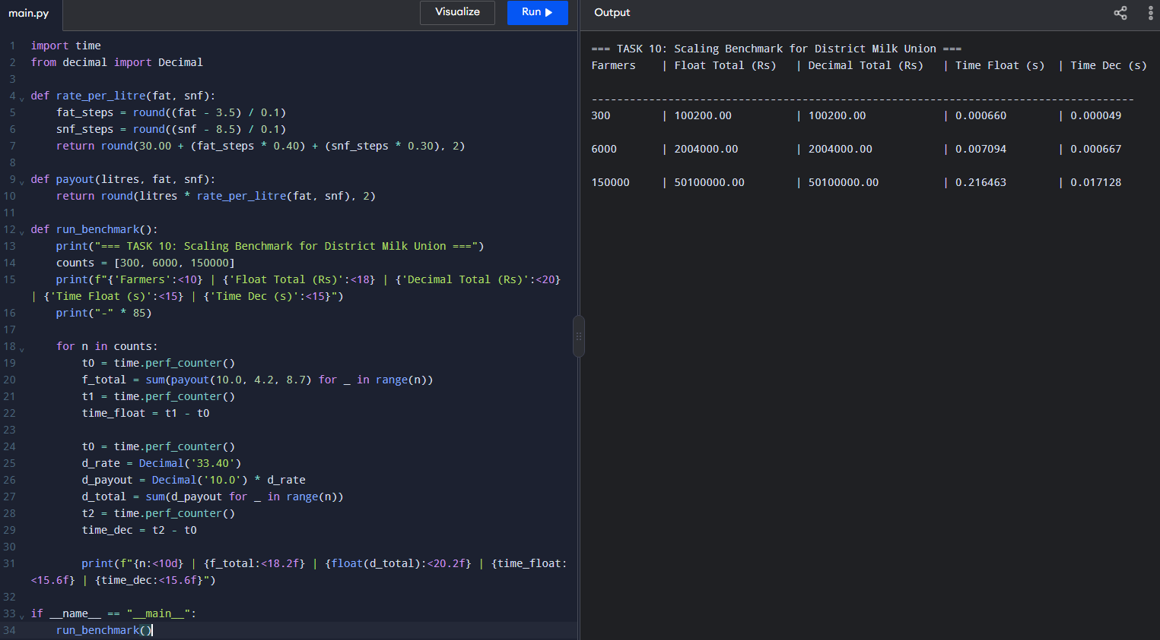
TASK 11 — Recommend and Defend the Final Design
1. Recommend suitable data types and a monetary rounding strategy.
The following data types are recommended for the milk payment calculator:
Data | Recommended type | Reason
Farmer ID | str | Preserves IDs that may contain leading zeros or letters.
Milk quantity | Decimal or float | Represents the quantity of milk received. Decimal is preferable when exact decimal representation is required.
Fat percentage | Decimal or float | Stores the fat percentage used in the rate calculation.
SNF percentage | Decimal or float | Stores the SNF percentage used in the rate calculation.
Shift | str | Stores values such as morning or evening.
Rate and payment | Decimal | Avoids the usual binary floating-point representation errors in monetary calculations.
Ten-day total | Decimal | Supports accurate addition of monetary values.
For money, I recommend using Python's Decimal class and constructing monetary values from strings, such as Decimal("33.40"), rather than from floating-point values.
The program should apply a consistent rounding policy. For example, ROUND_HALF_UP can be used to round each payment to two decimal places if the co-operative's accounting rules require rounding each individual payment.
from decimal import Decimal, ROUND_HALF_UP
payment = Decimal("283.90")
payment = payment.quantize(
Decimal("0.01"),
rounding=ROUND_HALF_UP
)
print(payment)
Output:
283.90
The rounding policy must be applied consistently when calculating individual payments and the final total.
2. Explain how a rate revision can be implemented safely.
The rate card should be defined in one place using named constants or a central configuration file.
Example:
BASE_RATE = Decimal("30.00")
FAT_STEP_VALUE = Decimal("0.40")
SNF_STEP_VALUE = Decimal("0.30")
When the co-operative changes the rates, the values can be updated without modifying every calculation in the program.
A safe rate revision should follow these steps:
- Confirm and approve the revised rates.
- Update the constants or configuration file.
- Verify the new values and applicable limits.
- Run the existing test cases.
- Test normal, boundary and invalid inputs.
- Compare the new results with manually calculated expected payments.
- Record the effective date of the revised rate card.
For a larger system, rate cards should include version numbers or effective dates. This helps ensure that payments are calculated using the correct rates for the relevant period.
3. Identify the limitations of the design.
The proposed calculator has the following limitations:
- The fat percentage is restricted to the range of 2.0% to 7.0%.
- The design assumes that fat and SNF adjustments are calculated in steps of 0.1%.
- The rate formula depends on the specified base rate and adjustment values.
- The design must define how values between 0.1% steps are rounded.
- Incorrect input data can produce incorrect payments if validation is incomplete.
- A simple Python program does not automatically provide database storage, user authentication, backups or transaction management.
- The program requires additional features for maintaining farmer records and generating long-term reports.
These limitations should be considered before using the calculator in an actual milk co-operative.
4. Evaluate whether the design can support 150,000 farmers at district-union scale.
The basic calculation is computationally simple. Each entry requires a fixed number of arithmetic operations, so calculating a payment takes O(1) time. Processing n entries takes O(n) time.
If only a running total is maintained, the additional calculation space is O(1). If all records are stored in a list, the space complexity is O(n).
The design can perform the core calculations for 150,000 farmers, but its suitability for district-union use depends on more than the formula. A production system would need:
- A database to store farmer details and milk transactions.
- Input validation and duplicate-entry prevention.
- Secure access and user permissions.
- Reliable transaction handling and backups.
- Reports for daily and ten-day payments.
- Testing with realistic data volumes and multiple users.
- Monitoring of execution time, memory use and database performance.
Therefore, the calculation logic can scale to a large number of records, but the complete system must be tested under realistic conditions before it can be considered suitable for district-union operations.
5. Justify the recommendations using evidence from the experiments.
The earlier experiments compare float and Decimal totals, examine rounding behaviour and measure execution time for 300, 6,000 and 150,000 payments.
The expected totals for payments of ₹33.40 each are:
Number of payments | Expected total
300 | ₹10,020.00
6,000 | ₹200,400.00
150,000 | ₹5,010,000.00
These expected values provide a reference for checking the program's results.
The experiments also demonstrate that floating-point values can contain small representation errors and that different rounding policies can produce different totals. Therefore, Decimal with a clearly defined rounding policy is recommended for monetary calculations.
The execution-time measurements should be used to compare performance. The actual timings must be taken from the program's output because they depend on the computer and execution environment.
Recommendation: Use named constants or a central rate card, suitable input validation, Decimal for money, a consistent rounding rule and automated regression tests. For large-scale deployment, combine the calculation functions with a database and conduct load testing.
6. Additional Question — Rate Card Stored in a Text or JSON File
Question: Explain how a rate card stored in a text or JSON file would work. Compare the start-up time and space required to load t rate values with the maintenance effort involved in editing and redistributing the program after each rate revision.
Answer:
A rate card can be stored in a JSON file instead of defining every rate directly in the Python module. When the program starts, it reads the file, converts its contents into Python values and uses the loaded rates during calculations.
Example JSON file named rate_card.json:
{
"base_rate": "30.00",
"fat_step_value": "0.40",
"snf_step_value": "0.30"
}
The program can load the values as follows:
import json
from decimal import Decimal
with open("rate_card.json", "r") as file:
data = json.load(file)
BASE_RATE = Decimal(data["base_rate"])
FAT_STEP_VALUE = Decimal(data["fat_step_value"])
SNF_STEP_VALUE = Decimal(data["snf_step_value"])
print(BASE_RATE)
print(FAT_STEP_VALUE)
print(SNF_STEP_VALUE)
Using strings in the JSON file allows the monetary values to be converted directly to Decimal.
Comparison of the approaches
Method 1: Rates defined in the Python module
The rates are written directly in the source code as named constants.
- Start-up overhead for loading the rate values is minimal.
- Updating rates requires editing the source code.
- The updated program may need to be redistributed to every installation.
- Configuration and calculation logic are maintained together.
Method 2: Rates stored in a JSON file
The program loads the rate values when it starts.
- Loading t rate values takes O(t) time.
- The loaded rate data requires O(t) space.
- Rate revisions can be made by editing the JSON file without changing the calculation functions.
- The program must validate the configuration file and handle missing or invalid values.
- The updated file must be distributed securely to the relevant installations.
Comparison table
Factor | Rates in Python module | Rates in JSON file
Rate revision | Edit source code | Edit configuration file
Start-up loading | Minimal additional work | O(t) loading time
Memory for rate values | Depends on stored constants | O(t) for loaded values
Redistribution after revision | May require distributing updated program code | Usually requires distributing the updated JSON file
Validation | Can be checked in code | File contents must be validated
Maintenance | Suitable for small, stable rate cards | Suitable for frequently revised rates

7. Final Recommendation
The recommended design uses reusable functions, named constants or a central rate card, validated inputs, Decimal for monetary values and a consistent rounding policy. Automated tests should verify normal cases, boundary values and invalid inputs.
For 150,000 farmers, the calculation algorithm has suitable linear time complexity, but reliable district-union operation also requires database storage, security, backups, reporting and performance testing. A JSON configuration file can make future rate revisions easier to maintain without repeatedly changing the calculation code.
Source Code
def summarize_architecture():
print("=== TASK 11: Architectural Recommendations ===")
print("1. Data Type : Use decimal.Decimal for monetary calculations to ensure exact precision.")
print("2. Rate Storage: Move rate cards into external JSON/YAML config files for hot-reloading.")
print("3. Scalability : Stream processing maintains O(N) linear time and O(1) auxiliary memory.")
if __name__ == "__main__":
summarize_architecture()

Execution Evidence Screenshot
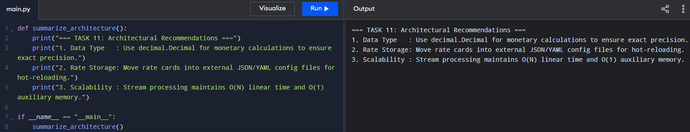
TASK 12 — DAY-4 DESIGN CHALLENGE: Re-evaluate and Adapt
A. Impact Analysis
1. What has changed from the original problem?
The original problem used a base rate of ₹30.00 per litre, with each 0.1% fat step worth ₹0.40 and each 0.1% SNF step worth ₹0.30. The revised problem introduces an automatic milk analyser that provides fat and SNF readings to two decimal places. From April to June, the base rate changes to ₹32.00 per litre, and each fat step is worth ₹0.45. Farmers supplying more than 500 litres during ten days receive a bonus of ₹0.50 per litre.
2. Which constants, expressions, and functions must be modified?
The following constants must be modified:
- BASE_RATE = 32.00
- FAT_STEP_VALUE = 0.45
- SNF_STEP_VALUE = 0.30
- BONUS_RATE = 0.50
- BONUS_THRESHOLD = 500
The rate calculation must support two-decimal analyser readings.
The rate_per_litre() function must use the revised seasonal rates, and the ten-day total function must calculate whether the farmer qualifies for the bonus. A separate bonus function can be created to keep the calculation organised.
3. How do two-decimal readings affect step calculations and rounding?
Two-decimal readings provide more precise fat and SNF values than one-decimal readings. Therefore, the number of steps should be calculated relative to the standard values and rounded to the nearest whole step. For example:
fat_steps = round((fat - 3.5) / 0.1)
snf_steps = round((snf - 8.5) / 0.1)
For a fat reading of 4.20%, the result is seven fat steps. For an SNF reading of 8.70%, the result is two SNF steps.
Using round() prevents small floating-point errors from incorrectly affecting the step count. Monetary amounts should be rounded to two decimal places using a consistent rounding rule.
B. Evaluation of the Original Design
The original design uses named constants and reusable functions, making it easy to modify and maintain. However, its original rate constants and calculations do not directly support seasonal rate changes, the revised fat-step value, or the ten-day bonus.
For example, with fat = 4.20% and SNF = 8.70%, the original calculation gives:
Fat steps = (4.20 − 3.50) / 0.10 = 7
SNF steps = (8.70 − 8.50) / 0.10 = 2
Original rate = ₹30.00 + (7 × ₹0.40) + (2 × ₹0.30)
Original rate = ₹33.40 per litre
Under the revised April–June rates:
Seasonal rate = ₹32.00 + (7 × ₹0.45) + (2 × ₹0.30)
Seasonal rate = ₹35.75 per litre
For 10 litres, the original payment is ₹334.00 if calculated using the original rate of ₹33.40 per litre. The seasonal payment is ₹357.50 using the revised rate of ₹35.75 per litre.
Therefore, the original design is a suitable starting point, but its constants and functions must be modified to support seasonal rates and bonus eligibility.
C. Adaptation or Redesign
I would modify the existing design instead of completely redesigning it. The program can retain reusable functions while accepting the season as a parameter and applying the correct rate card.
The revised rate calculation is:
BASE_RATE = 32.00
FAT_STEP_VALUE = 0.45
SNF_STEP_VALUE = 0.30
BONUS_RATE = 0.50
BONUS_THRESHOLD = 500
def rate_per_litre(fat, snf):
fat_steps = round((fat - 3.5) / 0.1)
snf_steps = round((snf - 8.5) / 0.1)
rate = (
BASE_RATE
+ fat_steps * FAT_STEP_VALUE
+ snf_steps * SNF_STEP_VALUE
)
return round(rate, 2)
def calculate_bonus(total_litres):
if total_litres > BONUS_THRESHOLD:
return round(total_litres * BONUS_RATE, 2)
return 0.00
def ten_day_total(payments, total_litres):
return round(sum(payments) + calculate_bonus(total_litres), 2)
This design uses separate functions for rate calculation, bonus calculation, and total payment. The bonus is applied only when the farmer supplies more than 500 litres during ten days.
This example assumes the bonus applies to all litres once the threshold is crossed. The co-operative should confirm this interpretation before final implementation.
D. Evidence-Based Defence
The modified design is preferable because it supports the new requirements while retaining the original program's reusable structure. Named constants make seasonal rate revisions easier, and separate functions reduce repeated code.
The following examples demonstrate the revised calculation:
Test case | Fat (%) | SNF (%) | Litres | Rate per litre | Bonus | Total payment
Seasonal rate | 4.20 | 8.70 | 10 | ₹35.75 | ₹0.00 | ₹357.50
Exactly 500 litres | 4.20 | 8.70 | 500 | ₹35.75 | ₹0.00 | ₹17,875.00
More than 500 litres | 4.20 | 8.70 | 510 | ₹35.75 | ₹255.00 | ₹18,487.50
For 510 litres, the milk payment is 510 × ₹35.75 = ₹18,232.50. Since the quantity exceeds 500 litres, the bonus is 510 × ₹0.50 = ₹255.00. Therefore, the total is ₹18,487.50.
At exactly 500 litres, no bonus is awarded because the requirement states more than 500 litres.
The main trade-off is that the revised program requires additional bonus logic and careful handling of two-decimal readings. However, these changes make the program easier to maintain and more suitable for the new requirements. The revised design should be tested using both the original and seasonal rates, with and without the bonus, before being used for actual payments.
Source Code
def revised_rate_per_litre(fat, snf, season="normal"):
base_rate = 32.00 if season == "summer" else 30.00
fat_step = 0.45 if season == "summer" else 0.40
snf_step = 0.30
fat_steps = round((fat - 3.5) / 0.1)
snf_steps = round((snf - 8.5) / 0.1)
rate = base_rate + (fat_steps * fat_step) + (snf_steps * snf_step)
return round(rate, 2)
def revised_payout(litres, fat, snf, ten_day_total_litres=0, season="normal"):
rate = revised_rate_per_litre(fat, snf, season)
if ten_day_total_litres > 500:
rate += 0.50
return round(litres * rate, 2)
if __name__ == "__main__":
print("=== TASK 12: Revised Calculator Verification ===")
p1 = revised_payout(50, 4.25, 8.72, ten_day_total_litres=600, season="summer")
p2 = revised_payout(50, 4.25, 8.72, ten_day_total_litres=400, season="normal")
print(f"Summer Season + High Volume (>500L) Payout: Rs.{p1}")
print(f"Normal Season Standard Payout : Rs.{p2}")

Execution Evidence Screenshot
